**CSSE 490: Human Computer Interaction  
  
Design Report**

*Dr. Çan Kultur*

*B. Keegan Gore  
Sarah Kim  
Seth Rujiraviriyapinyo*

*04 February 2015*

A modern website embodies the idea of “elegance through simplicity.” By reducing the number of clicks, tabs, and links on a page, web developers are able to deliver their message to the site’s audience without overloading them with information they may not need or want to see. The team’s goal is to incorporate lessons from the class, professional experience with modern tech giants, and user research from fellow students in order to design a website. The site will be devoted to shopping for wearables, and it will highlight the ability to develop for each wearable. Using a parallax display, the team will use modern page presentation techniques with universal design elements to develop an easily navigated, user centric, and modern approach to web development.

1. **Charter**

Team Members and Roles:  
Keegan Gore Editorial and User Research  
Sarah Kim Graphics and Design  
Seth Rujiraviriyapinyo Technical and Maintenance

Goals:  
 1) Development a modern, easily navigable site for exploring wearables  
 2) Provide information of wearable’s features and technical resources  
 2) Compare the Pros and Cons of different wearable products  
 3) Provide basic tutorials of common libraries/frameworks

Audience:  
The project is aimed at tech-oriented fitness enthusiasts who either already develop for wearables or who are interested in developing. The audience’s experience with development is intentionally broad as the site aims to excite and encourage new ideas and creativity from its users.

Deliverables  
By the end of the project, the team will have a well-designed, user centric website that embodies modern design. This site will be either in functioning form or in a highly refined mockup for demonstration. A report outlining design decisions, features, site layout, and overall design process will accompany the design to explain the team’s steps and thoughts throughout the project.

Success Metrics:  
The project will be successful if user’s can efficiently navigate the site and its features with ease. The team will use usability tests, user interviews, and potential user research to define these further.

1. **Information Architecture**

The website will original land on a welcome page introducing the site to its viewer. As the user begins scrolling, they will be asked to identify as either a “shopper” or a “developer.” Depending on which button they click on, the page will scroll further down revealing more information tailored to their needs.

For shoppers, the page will begin with a list of common features among wearables. Users can choose which ones they want, and a list will be generated below of matching wearables. The page will then prompt the shopper to select which wearables they wish to compare. After selecting the desired options, the screen will display the wearables side by side with their features to allow for easy shopping.

If the user identifies as a developer, the page will load a developer’s resource page. This page will contain information on available SDK’s and API’s and other resources. It can introduce some ideas to spawn creativity, or display user made applications to show the possibilities for them. This will be a more traditional style page in order reduce the busyness of a parallax design and utilize solid design.

At the bottom of the page will be a set of resources for shoppers to purchase or review items and also information for developers to join forums or begin programing. A floating header will provide a navigation bar for quickly moving from page to page in case users want to back step as well as quick links to resources for users who visit the page often.

1. **General Interface Design**

Navigation will be addressed through a portal, parallax scrolling and a floating header for shoppers, and a set of tabs for the developers.

Common aspects for the whole website will be a minimalist style and modern appeal with a focus on usability and universal design.

1. **Site Structure**

The parallax design was chosen to focus on simplicity for the user so that they can navigate the site in a linear path while still having a floating menu to navigate quickly if they know exactly where they want to jump to.

1. **Page Structure and Design**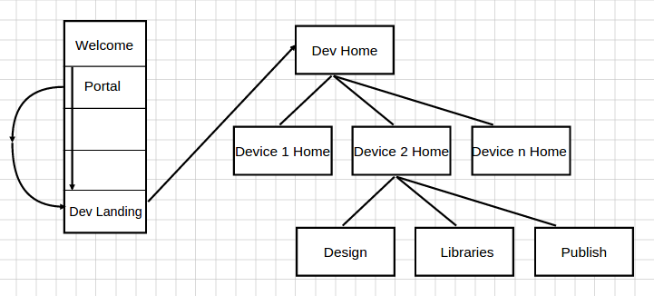

The page structure is such that they will be able to view one “slide” at a time as they scroll down the page, rather than clicking a button and being taken to another page.

1. **Strategy**

There are two primary user needs that this site is meant to address. The first being a way to find out which fitness tracker best meets their needs. Second is to provide resources to develop for wearable devices.

To address the first need the parallax homepage is meant to guide users through in learning about the devices. And the develop pages are meant to be a general source of knowledge and information about the device.

1. **Scope**

A

1. **Structure**

A

1. **Skeleton**

A

1. **Surface**

A

1. **Sources**
2. **Appendix - Deliverables**